**Project Initialization and Planning Phase**

| Date | 15 August 2024 |
| --- | --- |
| Team ID | LTVIP2024TMID24789 |
| Project Name | TrafficTelligence: Advanced Traffic Volume Estimation with Machine Learning |
| Maximum Marks | 3 Marks |

**Define Problem Statements (Customer Problem Statement Template):**

I **am** a **city traffic planner** responsible for managing traffic or commuting daily. **I’m trying to Optimize traffic flow** to prevent bottlenecks and congestion.But **Current traffic management methods are reactive, not predictive**, and rely on outdated models.Because Urban traffic is becoming more **complex and dynamic**, with increasing population and vehicle numbers. This makes me feel **frustrated** by recurring traffic delays and inefficiencies.

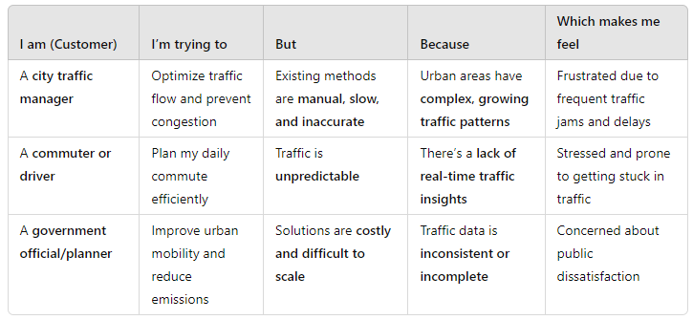

**Example:**

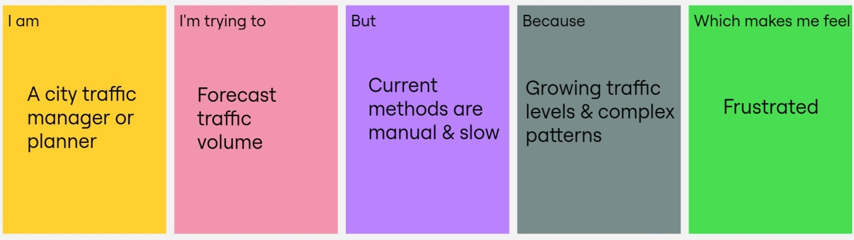

|  |  |  |  |  |  |
| --- | --- | --- | --- | --- | --- |
| **Problem**  **Statement (PS)** | **I am**  **(Customer)** | **I’m trying to** | **But** | **Because** | **Which makes me feel** |
| PS-1 | A city traffic manager or planner | Forecast traffic volume | Current methods are manual & slow | Growing traffic levels & complex patterns | Frustrated with inefficiency and delays |
| PS-2 | A public commuter or driver | Plan my daily commute | Traffic is unpredictable | Lack of real-time traffic insights | Stressed and prone to delays |